**Motion**

Projectile Motion

Practise Book 1

Name: ________________

General Consolidation

Some Advanced Questions

Give all answers to 3sf

Ask me if you are stuck on any of these and there are answers provided, too.

1) A Punter on an NFL team kicks a football with velocity 35 m/s at an angle of 40* to the horizontal. The ball is caught 0.3m above from where it was kicked.

a) Determine the initial horizontal and vertical components of the velocity?

**Ans: uv= 22.5 m/s uh= 26.8 m/s**

b) Determine the total flight time of the ball?

**Ans: 4.58s**

c) What is the horizontal distance the ball has travelled?

**Ans: 123m**

2) A helicopter is ordered to drop a care package to soldiers on the front line. The helicopter is travelling at a horizontal velocity of 45m/s and the care package is dropped when the helicopter is 150 m above the ground.

a) How long does it take for the package to hit the ground?

**Ans: 5.53 s**

b) If air resistance is accounted for, what happens to the time travelled, Vertical acceleration and horizontal acceleration?

**Ans: Time increased, Vertical acceleration unchanged, Horizontal increase**

3) A sport scientist wants to figure out how high on average a baseball player can hit. A particular subject hits the ball at an initial velocity of 60m/s at an angle of 1.3* to the horizontal. There is a wall of height 1m, 15.0 m away from the subject. Wil the ball clear the wall?

15 = (60cos1.3)t

t = 0.250s

sv = (60sin1.3)(0.250) – $\frac{1}{2}$ (9.8)(0.250)2 = 0.0340m

**Ans: No the ball will not clear the net since sv= 0.43 at that point < 1m**

4) A cricketer hits a target with a ball that is 100m away from him and is 6m high. He hits the ball at 58* to the horizontal.

a) What velocity must the ball be at when coming off the bat?

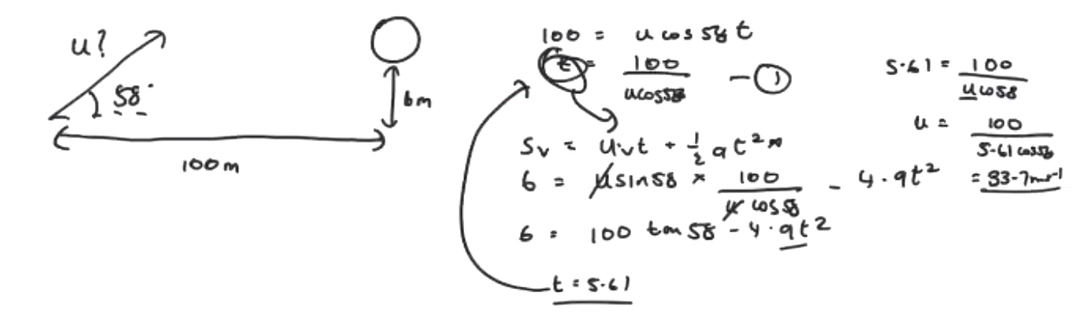

**Ans: 33.7m/s**

b) If he hits the same ball at 65* instead, with the same velocity will the ball hit the target? 